**Aim : Write a program to display Student marksheet**

using System;

usingSystem.Collections.Generic;

using System.Text;

namespace ConsoleApplication8

{

classGFG

{

staticvoid Main(string[] args)

{

int r, marks1, marks2, marks3, total;

float percentage;

string n;

Console.WriteLine("Enter Student Roll Number :");

r = Convert.ToInt32(Console.ReadLine());

Console.WriteLine("Enter Student Name :");

n = Console.ReadLine();

Console.WriteLine("Enter Subject-1 Marks : ");

marks1 = Convert.ToInt32(Console.ReadLine());

Console.WriteLine("Enter Subject-2 Marks : ");

marks2 = Convert.ToInt32(Console.ReadLine());

Console.WriteLine("Enter Subject-3 Marks :");

marks3 = Convert.ToInt32(Console.ReadLine());

total = marks1 + marks2 + marks3;

percentage = total / 3.0f;

Console.WriteLine("Final result of {0} is:", n);

Console.WriteLine("Total Marks : " + total);

Console.WriteLine("Percentage : " + percentage);

if (percentage <= 35)

{

Console.WriteLine("Grade is F");

Console.ReadKey();

}

elseif (percentage >= 34 && percentage <= 39)

{

Console.WriteLine("Grade is D");

Console.ReadKey();

}

elseif (percentage >= 40 && percentage <= 59)

{

Console.WriteLine("Grade is C");

Console.ReadKey();

}

elseif (percentage >= 60 && percentage <= 69)

{

Console.WriteLine("Grade is B");

Console.ReadKey();

}

elseif (percentage >= 70 && percentage <= 79)

{

Console.WriteLine("Grade is B+");

Console.ReadKey();

}

elseif (percentage >= 80 && percentage <= 90)

{

Console.WriteLine("Grade is A");

Console.ReadKey();

}

elseif (percentage >= 91)

{

Console.WriteLine("Grade is A+");

Console.ReadKey();

}

}

}

}

**Output:**dent Roll

Enter Student 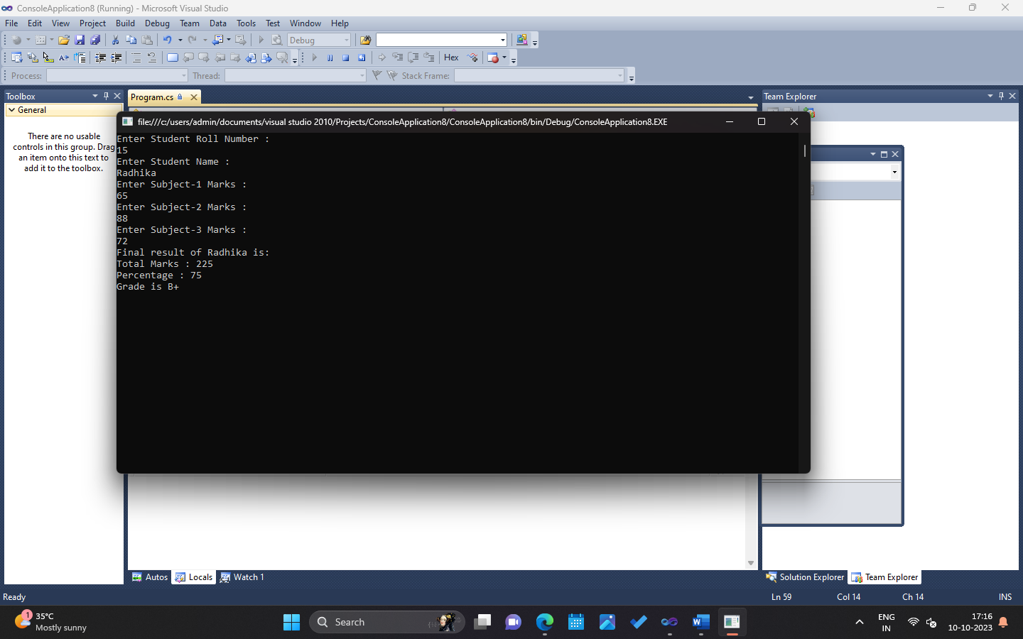 Subject-1Grade is

**Aim :Write a program to display Employee salary sheet.**

using System;

usingSystem.Collections.Generic;

usingSystem.Text;

namespace ConsoleApplication12

{

classProgram

{

staticvoid Main(string[] args)

{

DoubleBasic_Salary, DA, HRA, Gross_Salary;

Console.Write("Enter Basic Salary : ");

Basic_Salary = Convert.ToInt32(Console.ReadLine());

DA = (Basic_Salary * 40) / 100;

HRA = (Basic_Salary * 20) / 100;

Gross_Salary = Basic_Salary + DA + HRA;

Console.Write("\n\nDearness Allowance 40 % of Basic Salary : " + DA);

Console.Write("\nHouse Rent 20 % of Basic Salary : " + HRA);

Console.Write("\nGrossSalary : " + Gross_Salary);

Console.ReadKey();

}

}

}

**Output:**

